Apollo 2.0: Moon Program on Drugs

By Jeffrey F. Bell

Teaser: Many critics say that Mike Griffin’s planned Moon program is too much like Apollo to excite anyone. The real problem is that it is not enough like Apollo to be affordable.

For some time now, I have been reading comments on the Exploration Systems Architecture Study. As it is on every issue, the space community is deeply divided. Some love it, some hate it – and Bob Zubrin loves it and hates it simultaneously!

Many critics oppose this project because it “looks just like Apollo”, i.e. doesn’t involve fancy winged spaceplanes or other radically new technology. These people are wrong. The real problem with the ESAS architecture is that it isn’t enough like Apollo. It tries to achieve a major increase in mission capability with spacecraft and boosters that are too heavy, too expensive to develop, and too expensive to operate.

Rocket Redux? Externally, the ESAS study does look like an uninspiring rerun of Project Apollo. The CEV looks just like the Apollo CSM with solar panels. The lunar lander looks like the Apollo LM with a descent stage bloated up by the shift to LH₂ fuel. The overall mission plan is a combination of the competing Apollo EOR and LOR plans. Only the names have changed:

Element Apollo 1.0 Apollo 2.0
-------------- ---------- ----------
Return capsule CSM CEV
Lunar lander LM LSAM
TLI stage S-IVB EDS
LEO booster Saturn I CLV
Moon booster Saturn V HLV

But underneath this superficial similarity, Apollo 2.0 is actually much more capable than Apollo 1.0. It will land 2x as many astronauts for 2-4x the stay time as Apollo 1.0. The basic designs of the vehicles are intended to eventually allow 6-month stays on the Moon (although this would require a buried hab module, since the LSAM has no radiation protection).

Furthermore, Griffin has stated that the ESAS planners started with the requirements for the far-off manned Mars missions and made the Lunar hardware elements capable enough to serve similar roles in the Mars program. This is the reason for the only completely new technology in Apollo 2.0, pressure-fed methane/oxygen engines whose propellants can be synthesized from the Martian atmosphere.

The early hardware elements (CEV and CLV) are also designed to operate in LEO as support vehicles for the International Space Station after the Shuttle is retired in 2010. Currently there is an attempt to speed up development for these vehicles so they can take over this task in 2012 rather than 2014 as currently budgeted.

In my view, it is exactly this multiple-use design philosophy that make this program unworkable and unaffordable. Space vehicles need to be as light as possible. To achieve this goal, they need to be designed for specific functions. The CEV spacecraft developed in the ESAS study violates this basic principle and attempts to do five different missions with minor modifications to a single vehicle. This fundamental error makes the spacecraft too heavy, the boosters too big, and requires an absurd mission profile.

Spacecraft on Steroids: The weight problem starts with the basic command module design, which is just the old Apollo CM scaled up from 3.9m in diameter to 5.5m. This implies that the CEV is about three times larger in “displacement” than Apollo:

Apollo Vs. CEV

Spacecraft Apollo CEV Bloat
Parameter CM CM Factor
----------- -------- -------- -----
CM Diameter 3.9m 5.5m x1.41
CM Surface x1.99
CM Volume x2.80
CM Mass 5,806kg 9,237kg x1.59

Why is this vehicle so big? The original Apollo 1.0 command module held three men for lunar missions and could have carried six for space station ferry flights. (CM-119 was actually modified to a 5-seat+cargo configuration for an abortive Skylab rescue mission.) If we redesigned Apollo today, it would have even more internal space due to advances in electronics that would reduce that huge analog control panel to a flat-panel display and a trackball.

The new CEV command module will carry only four astronauts to the Moon or three to ISS, despite being 3 times bigger. It ought to carry a lot more seats. Andrews Space has produced a CAD drawing of a 10-seat CEV and a very similar craft was proposed in the late 1960s as a 12-man space station ferry vehicle!

This mystery is not solved by examining the conceptual CEV design presented to an NAS panel, which reveals that most of this extra space is allocated to... nothing:

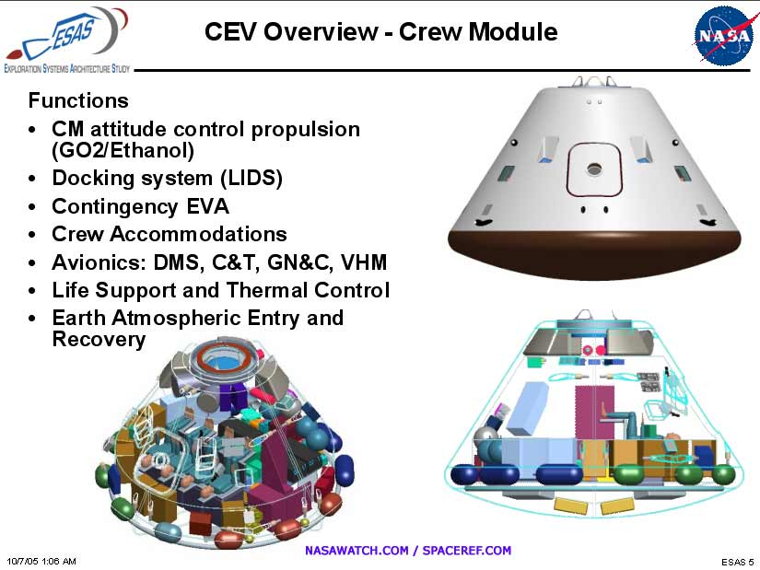

The four lunar astronauts hang in the middle of a huge empty pressure cabin. It almost looks like a space gymnasium.
What possible use is all this space on a short trip to the Moon, or the even shorter Earth-entry phase of a Mars mission?

Another slide shown to the NAS review panel reveals that their are actually five different CEV designs, the first three of which are intended to support the Space Station.

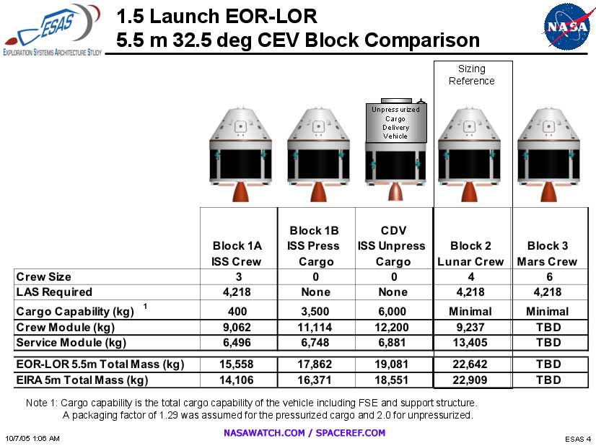

The only one of these designs which could possibly use all that cabin space is Block 1B which is intended to carry 3500kg of “Pressurized Cargo” to keep the International Space Scrapyard in good repair. This ISS support requirement is clearly the tall pole in the overall design,

This slide tells us that the ESAS program is not really designed “from the top down” as Griffin claims, but rather “from the bottom up”. The Mars return capsule which Griffin claims to be the basic CEV version has not yet been designed and doesn’t even have a weight budget!

Like all multi-purpose aerospace vehicles, this compromise spacecraft is not very effective at any of its assigned functions. Let’s compare it with some real spacecraft that are optimized for each mission:

Proposed CEV Versions vs. Existing Spacecraft

Spacecraft Crew Cargo CM Mass SM Mass Ttl Mass Mission
--------------- - ------ -------- -------- -------- -----------------------
Soyuz TMA 3 100kg 2,950kg 7,220kg ISS crew exchange
CEV Block 1A 3 400kg 9,062kg 6,496kg 15,558kg ISS crew exchange
Apollo CSM-119 5 ?kg 16,800kg Skylab Rescue

CEV Block 1B 0 3,500kg 11,114kg 6,748kg 17,862kg ISS pres. crgo & return
CDV Block 1C 0 6,000kg 12,200kg 6,881kg 19,081kg ISS unpres. crgo up
ATV Jules Verne 0 10,280kg 20,750kg ISS press. cargo up
Progress M1 0 2,230kg 7,450kg ISS press. cargo up

CEV Block 2 4 Minimal 9,237kg 13,405kg 22,642kg Lunar return
Apollo CSM 3 Minimal 4,806kg 24,523kg 30,329kg Lunar braking & return

The Service Module weights are not comparable because of the higher ISP fuels used by Apollo 2.0 and the fact that the SM engine only burns once for TEI. But the other figures clearly show that the CEV is about half as efficient as Apollo or Soyuz as a crew transport and much inferior to ESA’s ATV as an up-cargo transport. Its only advantage is that it can bring down a large amount of down-cargo from the ISS – mostly worn-out or broken equipment that needs to be repaired and relaunched. This is a requirement inherited from the old “Alternate Access to Station” program of two years ago – although it would take about 10 flights per year of Block 1B CEVs to meet the down-cargo mass flow specified back then.

Of course, the idea of the CEV as an ISS ferry vehicle makes no sense in the context of President Bush’s VSE plan. The Block 1A CEV will make its first manned flight in 2012-2014, while the US will withdraw from the ISS project in 2016.
This is not enough time to develop Block 1B or Block 1C, or even use Block 1A often enough to justify its development.

My informants at NASA confirm that Block 1A is only intended as a test vehicle for the Block 2 lunar version, and that only a few missions to the ISS are actually planned. Clearly, the other two Block 1 variants presented to the NAS panel are intended as a hedge against the possibility that a Democratic president will cancel the VSE in 2009 and order NASA back to long term ISS participation (this apparently was John Kerry’s intention).

The LSAM lunar lander is still only a conceptual design, but we can predict that it will be a lot heavier than the old LM. It carries twice as many crew for a longer stay time. In order to give those 4 astronauts something to do for a week, it must carry 2 lunar rovers and a variety of scientific gear. And since a much larger number of interesting rocks will be collected, the ascent stage must lift more cargo. (The 15,000lb methane ascent engine implies that this stage will be about 4x the weight of the LM ascent stage.)

More importantly, the LSAM descent stage has to brake the combined spacecraft into lunar orbit. This LOI burn was done by the Service Module engine in Apollo 1.0, but by transferring this work to the LSAM DS it acquires the ability to serve as a dedicated cargo vehicle capable of landing ~21 tonnes on the Moon in place of the ascent stage. Since the HLV can boost about 54 tonnes toward the Moon, the LSAM descent stage probably weigh about 33 tonnes.

Boosters on Viagra: These oversized spacecraft require oversized boosters. The two Shuttle-derived launch vehicles are now considerably longer and heavier than they were in earlier studies.
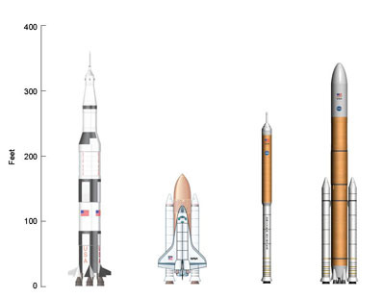
The CLV’s upper stage has doubled in length and mass since it was first studied by the Planetary Society. The original J-2S engine has been replaced with an SSME modified for air start.

With a tall lightweight hydrogen stage on top of a narrow dense SRB, the c.g. of the entire stack will be very far aft. The control dynamics of the CLV are likely to be unfortunate. Some early CLV concepts showed tailfins added to increase stability, but apparently these have been abandoned because they would interfere with parachute deployment.

The heavy-lift booster seems to have gotten the same overdose. The core stage has 5 SSMEs instead of 4, requiring the Shuttle ET to be stretched considerably. The original small upper stage with one J-2S has been merged with the Earth Departure Stage to make a double-burn stage analogous to the S-IVB (except that this one has two “J-2S+” engines and has to make its second burn after spending up to 30 days in space).

Budget on Growth Hormones: The main justifications for preserving so much 1970s Shuttle technology in Apollo 2.0 are:

1) it will speed up development and therefore reduce the length of the inevitable gap in US manned spaceflights.

2) it will reduce development costs so that the early stages of the program can be carried out in parallel with a continued Shuttle/ISS program.

The problem with these claims is that virtually every Shuttle element has go through a major redesign before it can be used in the new boosters.

The Shuttle SRBs burn in parallel with the Orbiter engines and derive their electrical power and control signals from the Orbiter’s systems. The CLV SRB needs its own guidance system and power supplies.

Any single-engine booster stage needs a separate roll control system. The SRB doesn’t have any turbopump exhaust to perform this function, so it will need either liquid vernier engines or a solid-fuel gas generator grafted on somewhere. (Possibly this function can be provided by the new upper stage since its single SSME also can’t control it in the roll axis.)

The SSME is designed to be started up at sea level with assistance from ground support equipment. Rocketdyne estimates that modifying it for an unassisted air start will take at least three years. The upper stage itself will have to be a completely new design because no existing stage has its extremely thin proportions.
The HLV is even more removed from current Shuttle technology than the CLV. It uses enlarged 5-segment SRBs which will be considerably different in detail from those used on Shuttle and CLV. They will require an extensive testing and qualification program.

The HLV core stage is to be based on a Shuttle External Tank, but it must be completely redesigned. The current ET carries the payload and the engines mounted on one side. The tank was carefully designed to carry these off-center stresses.

The in-line design of the HLV requires a very different ET. It has to stretched considerably to carry a much larger weight of propellants. It needs carry the EDS stage and payload on top and no less than 5 engines on the bottom. The stress distributions will be totally different. The propellant feed pipes and wiring harness will be more elaborate. All this adds up to a complete redesign and considerable extra weight.

So the CLV and HLV will be essentially new designs, requiring massive engineering analysis and an extensive ground-testing program. This R&D effort will be very expensive. The estimated R&D cost for the CLV alone has ballooned from $1.5B in the original studies to around $5B today. This booster is “Safe, Simple, and Soon” only in Thiokol’s propaganda.

The Earth Departure Stage and the spacecraft will require even more development. The traditional corrosive hypergolic propellants have been replaced with cryogenics. The LCH₄ and LO₂ in the CEV and LSAM ascent stage must be stored in space for 6 months. The LH₂ and LO₂ in the EDS and LSAM descent stage may have to be stored in Earth orbit for 1 month while waiting for the CEV and crew to be launched separately. This will require the development of superinsulation or compact reliquification plants.

Even more money will be spent on rebuilding Launch Complex 39 to accommodate the new boosters. The Saturn umbilical towers were cut down to service the stubby Shuttle and cannot service the new super-tall boosters. New mobile launch platforms must be built to accommodate the HLV. Specialized work platforms and fixtures will have to be installed in the VAB high bays. The decay to the entire LC-39 facility from decades of deferred maintenance needs to be repaired. NASA officials have spoken of using new computers and automated checkout equipment to reduce the army of support personnel.

Acid Trip Mission Plan: But the most dubious aspect of Apollo 2.0 is the EOR+LOR or “1.5-launch” mission plan. Two boosters need to be launched for each mission. And they are not identical boosters as in von Braun’s Apollo 1.0 EOR plan. The HLV and CLV are very different boosters with different components. They will require two separate launch prep teams at the Cape, separate bays in the VAB, separate mobile launch platforms, and probably separate pads.

The hardware employed in these 1.5 launches adds up to about double that used in a Shuttle launch: 6 SSMEs instead of 3, 14 SRB segments instead of 8, at least 4 smaller cryogenic engines. The effort at KSC required for each moon mission will be roughly equivalent to preparing and launching two Shuttles simultaneously. Any defect found in either booster will lead to a delay in both launches. Considering the frequent delays and mission cancellations that have occurred in the Shuttle program, it seems unlikely that lunar missions could be launched on any kind of regular schedule.

One might space out the two launches by days or weeks in order to share some of the equipment and personnel. But consider the situation once the HLV is launched and waiting in LEO. The EDS and LSAM have an orbital life of only 30 days due to the boil-off of their cryogenic fuels. This ticking clock will hang over the heads of the program managers as they prepare for the manned launch of the CLV. If the CLV is delayed too long for safety reasons, the whole mission has to be written off as a dead loss. Inevitably, those managers will be forced to ignore problems and launch anyway – just like they did with Challenger and Columbia.

Furthermore, the SSMEs are not recoverable and so NASA will be dropping 6 of them in the ocean on each Moon mission. The current stock of 11 Block II SSMEs will scarcely be enough for test flights. Clearly Rocketdyne will need to produce new SSMEs at a rate of at least one per month to support the projected two moon landings per year.

These engines are the most expensive and complicated rocket engines ever designed, due to their high performance and reusability requirement. They take about three years to build from scratch. Their quoted new-build cost is $60M, but it may be higher because no completely new SSME has been built for years. This part of the program alone could well end up absorbing over $1B per year.

Rocketdyne has proposed a down-engineered disposable version of the SSME that will allegedly cost only $40M per copy.
Of course this engine doesn’t exist and must be developed and tested at huge cost.

And there is a technical problem with EOR+LOR that no one seems to have noticed: During the TLI and LOI burns, the CEV is docked nose-down with respect to the engines. The unfortunate astronauts will be hanging from their seat straps, taking the g-forces in the uncomfortable “eyeballs-out” position. Possibly the lunar CEV will have rotatable seats.

An orgy of pork: The basic problem with the ESAS program, from which all the technical problems I have enumerated above derive, is that it isn’t really a space program at all. It is a vote-buying program.

Everything about the ESAS architecture is optimized for political advantage, not efficiency. Every current Shuttle contractor and every NASA Center gets to stay at the feeding trough. And this program will need a lot of feeding.

Just consider the R&D money that will be going to the Usual Suspects for the following new rocket engines:

1) Thiokol 4-seg SRB modified for the CLV
2) Thiokol 5-seg SRB developed for the HLV
3) Rocketdyne/Pratt & Whitney air-start SSME for the CLV
4) Rocketdyne/Pratt & Whitney disposable SSME for the HLV
5) Rocketdyne J-2S+ for the EDS
6) Pratt & Whitney throttleable RL-10 for the LSAM
7) 15Klb pressure-fed methane-LOX engine
8) ethanol-GOX RCS thrusters

How much money will this vast rocket (re)development program cost? The recent history of NASA and its contractors on similar projects is not very encouraging.

The only major Shuttle upgrade that actually proceeded to hardware was the Advanced Solid Rocket Motor. When contracts were awarded to Lockheed and Aerojet in March 1990, the ASRM was to be flight-ready by 1996 at a cost of ~$1B. By March 1993, projected R&D costs had risen to $3.5B and the first flight was expected in 2000. Congress cancelled the program in October 1993 after $2.2B had been wasted, and the ASRM factory and tooling were auctioned off without ever being used.

As for liquid engines – NASA’s only recent attempt at a clean-sheet design was the Fastrac ultra-simple engine for the X-34. This development was a complete failure that dragged the whole X-34 project down to destruction. In view of this it seems foolish to tie the CEV to a completely new engine using a completely new fuel, just because that engine might be useful 30 years from now on a Mars mission that hasn’t been designed yet.

On the Moon to stay? The most dubious aspect of the ESAS architecture is the idea that it could serve as the basis of a permanent lunar base. Griffin seems to envisage a 4-man base, whose crews would be exchanged every 6 months.

The problem here is that the whole ESAS architecture is scaled around 2 HLV launches and 2 CLV launches per year. This is just enough to replace the crews, but makes no provision for initial construction of the base or resupply. There would have to be several initial HLV launches to bring up the habitation modules, plus a nuclear reactor for power. Then when the base is “operational” there would have to be extra launches every year for food and water, plus replacement parts, plus science gear, plus Mars equipment to be tested, etc.

So HLV production has to be increased to at least 4/yr and SSME production has to rise to 22/yr! Clearly this cannot be afforded within a constant NASA budget. This is exactly why the old Apollo Applications program was cancelled – there simply was no possibility of purchasing the huge number of Saturn Vs that would have been needed to support a Moon base.

In a recent speech, Griffin implicitly confirmed this analysis when he stated that a permanent presence on the Moon would require major participation by other nations – the same nations that have been carefully excluded from the earlier stages of the ESAS program!

Griffin also has outlined a manned Mars mission to be assembled by 6-8 HLV flights launched at intervals of 5-6 weeks. Again, one only has to look at the history of Saturn V and Shuttle launches to see how impossible this is, at least without massive budget increases.

A Leninist Space Program? Griffin is certainly aware of the fact that excessive development or operations costs could kill the VSE. He has stated the kind of spacecraft and boosters he wants:
"We need a system that needs a smaller support base, if we expect to keep alive. The only way to do that is to use fewer people... I firmly believe that if a few [Navy] officers and enlisted men can launch a Trident D-5 out of a submarine that stands off-shore from the Cape here, that we ought to be able to find a way to have a comparable number of people to launch our space vehicle ... If we design another space launch system that requires $4.5B per year to do no launches at all, then we will be put out of business!" –Mike Griffin, 16 Nov. 2005 at KSC
Clearly, the ESAS boosters won’t meet Griffin’s goals. Since they are constructed out of Shuttle parts, they will also suffer from the same problems of excessive complexity, high costs, high demand for skilled labor, and frequent safety stand-downs that have crippled the Shuttle and ISS programs. The VSE as currently constructed will indeed “require $4.5B per year to do no launches at all”, and probably a lot more to achieve the stated goal of two Moon landings per year.

From this analysis it might appear that Mike Griffin is an idiot. I don’t think so. These problems with the ESAS architecture aren’t Griffin’s fault. He is working within a variety of absurd constraints laid down by White House staffers and Congressmen that force him to waste vast amounts of money on subsidiary goals (like ISS) and political pork (like SRB and SSME). These politicians just don't understand how difficult manned space flight really is. They have laid down goals that are simply impossible to meet within the proposed level NASA budget.

I suspect that Griffin’s strategy is akin to Lenin’s: things must be made much worse before they can get better. By rigidly conforming to the dictates of his political masters he has proven how absurd the overall VSE plan is. Already the Vision is colliding with reality in the form of the $3-6B cost overrun in Shuttle ops. It will soon become clear even to politicians that the plan as announced in January 2004 is unworkable and must be radically modified – probably by canceling Shuttle and ramping back US participation in the ISS.

Once this inevitable decision is made, the ESAS study could actually serve as the basis of a workable manned Moon program. In a future column I will outline how it could be simplified and de-porked enough to fit inside the budget wedge that is likely to be available.
Jeffrey F. Bell is a former space scientist and recovering pro-space activist.

